12. Applications & SDG’s
The proposed disaster communication system can be applied across multiple real-world scenarios where fast, clear, and reliable communication is essential. It is designed not only for natural disasters but also for various emergency and public safety situations, ensuring that citizens receive timely and actionable information.
- Key Applications:
- Urban Flood Management Systems
The platform can be used in flood-prone cities like Mumbai to send real-time alerts about waterlogging, heavy rainfall, and unsafe zones. It helps citizens avoid affected areas and take preventive action early.
- Road Accident and Highway Emergency Alerts
Authorities can use the system to instantly notify users about major road accidents, traffic diversions, and highway blockages. This improves emergency response and reduces secondary accidents.
- Cyclone and Weather Warning Systems
The system can deliver early warnings for cyclones, storms, and extreme weather conditions with clear safety instructions, helping reduce loss of life and property.
- Earthquake and Sudden Disaster Alerts
In case of sudden disasters like earthquakes, the system can immediately broadcast simplified alerts with safety steps such as “Drop, Cover, and Hold.”
- Railway and Public Transport Safety Alerts
The platform can be integrated with railway systems to inform passengers about delays, disruptions, or emergencies in real time.
- Public Health and Emergency Situations
It can also be extended to health emergencies such as disease outbreaks, where authorities can issue preventive guidelines and safety measures.
- Smart City Disaster Management Systems
The system can be integrated into smart city infrastructure to create a unified emergency communication network across departments.
- UN Sustainable Development Goals (SDGs)
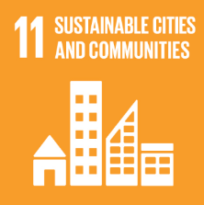
SDG 11 – Sustainable Cities and Communities
This goal focuses on making cities inclusive, safe, resilient, and sustainable. The proposed system supports this by improving disaster preparedness and ensuring efficient communication during emergencies. By providing location-based and structured alerts, it helps reduce urban risks and enhances safety in densely populated areas. The system contributes to building smarter cities where citizens receive timely and understandable information during crises.
SDG - 11

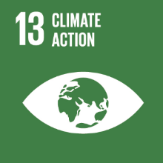
SDG 13 – Climate Action
SDG 13 emphasizes urgent action to combat climate change and its impacts. The system supports this goal by enabling rapid communication during climate-related disasters such as floods, cyclones, heavy rainfall, and heatwaves. Early warnings and clear instructions help reduce the impact of climate-induced hazards and improve community resilience. It ensures that citizens are better prepared for extreme weather events caused by climate change.
SDG - 13


SDG 16 – Peace, Justice and Strong Institutions
This goal focuses on building strong, accountable, and transparent institutions. The proposed system enhances institutional effectiveness by providing structured, verified, and consistent communication between authorities and the public. The inclusion of feedback mechanisms improves transparency by allowing authorities to measure public understanding of alerts. It also helps reduce misinformation, thereby increasing trust in government communication during emergencies.
SDG - 16

